|  |  |
| --- | --- |
| **Assignment Case** |  |
| COMP6799001  Database Technology |
| **Computer Science** | **O233-COMP6799001-LH18-01** |
| ***Valid on*** *Odd Semester Year 2022/2023* | **Revision 00** |

1. Seluruh mahasiswa tidak diperkenankan untuk:

*All students are not allowed to:*

* + - Berdiskusi dan/atau bekerja sama dengan mahasiswa lainnya,

*Discuss and/or work together with other student participants,*

* + - Melihat sebagian atau seluruh jawaban mahasiswa lain,

*Seeing a part or the whole answer from another student,*

* + - Membuka dan menyalin dari **BUKU** atau **CATATAN**, **VIDEO** dari pengajar (recording kelas, VBL, Youtube, dsb) dan **REFERENSI** lainnya,

*Open and copy from any resources such as notes, videos (class recording, VBL, Youtube, etc) and other references,*

* + - Membuka dan menyalin jawaban dari internet (google, stackoverflow, dsb),

*Open and copy answer from the internet (google, stackoverflow, etc),*

* + - Mengerjakan soal yang tidak sesuai dengan tema yang ada di soal,

*Working with another theme which is not in accordance with the existing theme in the matter of the case,*

* + - Melakukan tindakan kecurangan lainnya,

*Committing other dishonest actions,*

* + - Secara sengaja maupun tidak sengaja melakukan segala tindakan kelalaian yang menyebabkan hasil karyanya berhasil dicontek oleh orang lain / kelompok lain.

*Accidentally or intentionally conduct any failure action that cause the results of the project was copied by someone else / other groups.*

1. Jika mahasiswa terbukti melakukan tindakan seperti yang dijelaskan butir 1 di atas, maka **nilai mahasiswa** yang melakukan kecurangan (menyontek maupun dicontek) akan di – **NOL** – kan.

*If the student is proved to the actions described in point 1 above, the score of the student which committed dishonest acts (cheating or being cheated) will be “Zero”.*

1. Perhatikan jadwal pengumpulan jawaban, segala jenis pengumpulan jawaban di luar jadwal tidak dilayani.

*Pay attention to the submission schedule, all kinds of submission outside the schedule will not be accepted.*

1. Bila Anda tidak membaca peraturan ini, maka Anda dianggap telah membaca dan menyetujuinya

*If you have missed to read these regulations, so you are considered to have read and agreed on it.*

1. Persentase penilaiaan untuk matakuliah ini adalah sebagai berikut:

*Marking percentage for this subject is described as follows:*

|  |  |  |
| --- | --- | --- |
| **Tugas Mandiri**  *Assignment* | **Proyek**  *Project* | **UAP**  *Final Exam* |
| 40% | - | 60% |

1. Software yang digunakan pada matakuliah ini adalah sebagai berikut:

*Software will be used in this subject are described as follows:*

|  |
| --- |
| **Software**  *Software* |
| XAMPP 8.0.7 |

1. Ekstensi file yang harus disertakan dalam pengumpulan tugas mandiri, proyek, dan uap untuk matakuliah ini adalah sebagai berikut:

*File extensions should be included in assignment, project, and final exam collection for this subject are described as follows:*

|  |  |  |
| --- | --- | --- |
| **Tugas Mandiri**  *Assignment* | **Proyek**  *Project* | **UAP**  *Final Exam* |
| SQL | - | SQL |

**Tabel Relasional**

*Relational Table*

**Jetify**

**Jetify** is a company that sells Songs Album in Indonesia. It has many songs collected from various country like China, Korea, and the others. It has a database that describe by ERD below.

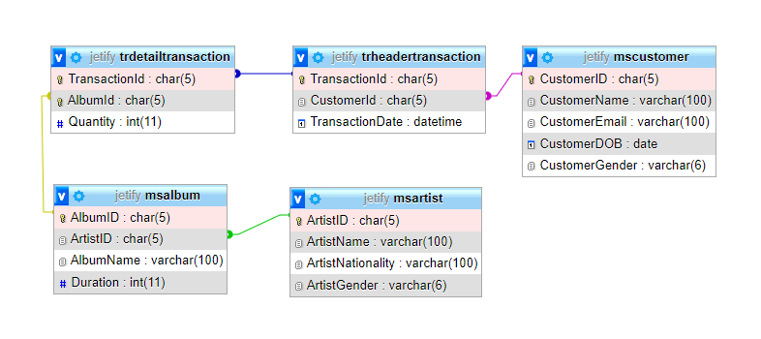

## Soal

*Case*

**Note**: Import ‘jetify’ database before answering the questions below.

1. Create table **MsStaff** with specification as below.

(**CREATE TABLE**)

|  |  |  |  |
| --- | --- | --- | --- |
| **Column Name** | **Data Type** | **Length** | **Constraint** |
| StaffId | CHAR | 4 | Primary Key. StaffId must starts with ‘S’ and followed by 3 digits of number.  Example: S123, S101 |
| StaffName | VARCHAR | 100 | Cannot be empty. |
| StaffGender | VARCHAR | 6 | Cannot be empty. |
| StaffAddress | VARCHAR | 100 | Cannot be empty. StaffAddress must ends with ‘ street’ |

1. Insert this data below to **MsStaff** table:

(**INSERT INTO**)

|  |  |  |  |
| --- | --- | --- | --- |
| StaffId | StaffName | StaffGender | StaffAddress |
| S001 | Mark Zulcan Vinesca | Male | Andamite 15 street |

1. Display **AlbumID**, **AlbumName**, **ArtistName**, and **ArtistNationality** for every album created by **Male** Artist.

(**LIKE**)

1. Display **TransactionId**, **TransactionDate**, **AlbumId**, **Quantity**, **CustomerName**, and **Gender** (obtained from the **first letter** of CustomerGender) for every customer that was born on **1990** and make an item purchase for **more than 10**.

(**LEFT**, **YEAR**)

1. **Delete** MsAlbum where the ArtistName's length is more than 22.

(**DELETE**, **CHAR_LENGTH**)

Before delete:

After delete:

**If you do not understand, please ask your assistant! Do not make your own assumption!**